*Posted on February 24th, 2014*

**COMP 361 - Network Diagrams**

The network I have chosen from the ratemynetworkdiagram.com website is for a company which purchased a voice solution from another vendor. Here is the diagram:

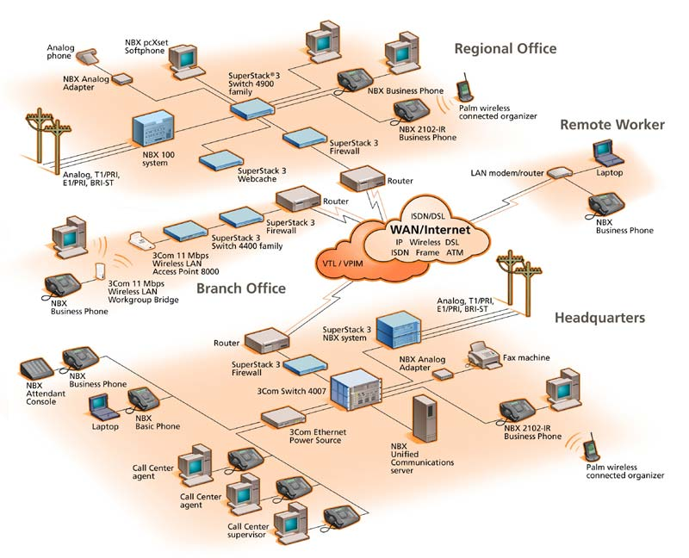[1]

The network depicted connects regional offices, branch offices and remote workers with the company headquarters via the Internet. Each section has at least one phone connected to the network to provide the voice solution, many of which are additionally connected to analog phone lines. Each location accesses the internet through a router, and all except the remote worker are protected through various firewalls. The diagram integrates both LAN and WAN into the solution as well.

The creator of the diagram, testuser23, mentions the main advantages of the network; it's flexibility and cost effectiveness [2]. This networking solution allows connection of all offices to each other, and it provides a certain amount of redundancy because some of phones are additionally connected to analog lines. That way, if the network goes down the voice capabilities are not completely lost. Some of the other advantages are that each office/remote worker can work independently of the entire network, and the network allows for the connection of many types of directly connected and wireless devices.

However, this type of solution does present one major problem, in that does not seem to be fully redundant. Each LAN is connected to the phone line over the network, and some are not connected to phone lines at all. This means that local network failure will disable voice communication for the entire area office or individual worker. This can obviously cause problems while waiting for the network to come back online. There does not seem to be enough redundancy built into the network to handle this situation. This can be overcome by having a more direct connection to the outside phone lines, or by providing a backup router or "NBX system."

**References**

[1],[2] testuser23, *ratemynetworkdiagram.com,* accessed January 30, 2014, <http://www.ratemynetworkdiagram.com/>.